* Attributes are the extra add-ons that you use in tags.

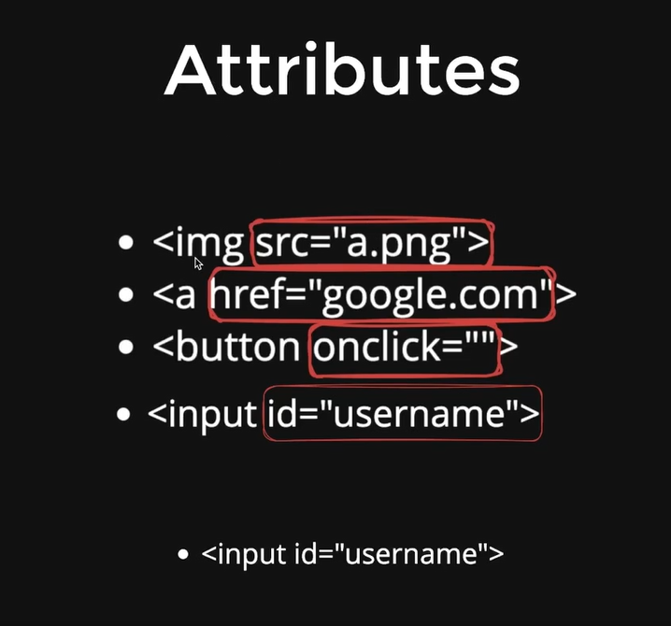

* CSS (Cascading Style Sheet):

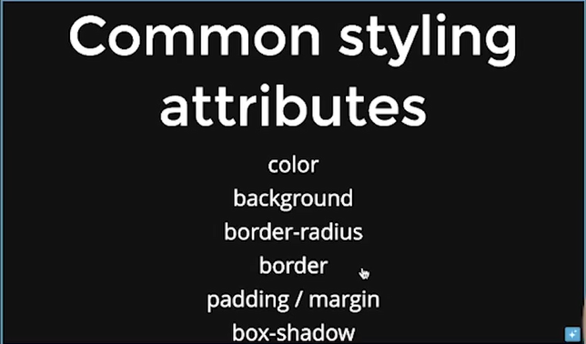

* Divs take up all the space available horizontally , spans only take up as much space as needed.

<div>

    <img width="150" src="logo.svg" alt="logo"></img>

    <span>Signup</span>

    <span>About</span>

    <span>Product</span>

    <span>Pricing</span>

    <span>Support</span>

</div>

</br>

</br>

<*center*>

    <img width="800" src="landing.png" alt="landing log"

*</center*>

</br>

</br>

<h1 style="background-color: green;color: aqua">Invest in everything</h1>

<h3>Online platform to invest in stocks, derivatives, mutual funds, ETFs, bonds, and more.</h3>

* Button tags:
* <button style="border : 1px dotted black">Sign up for Free</button>
* Padding and margin: Padding gives some breathing space inside the border and margin gives some breathing space outside the button.
* <button style="padding : 10px;border: 5px solid black; margin : 200px">Sign up for Free</button>
* Border-Shadow:

Box-shadow : 20px 10px 10px black; Here 20px means the shadow comes at right. -20px means the shadow comes at left.

Secondly, 10px means shadow at downside, how much shadow to be seen.

Third , 10px means how much dark the shadow should be. For 1px it is darker, then the number is increased the shadow becomes light in seeing.

<button style="box-shadow : 10px 20px 1px black">Sign up for Free</button>

* FlexBox:

Style=”display : flex” (This is like a parent)

This will bring the content added in one div tag in one line.